OFFICIAL COORDINATION REQUEST FOR
NON-ROUTINE OPERATIONS AND MAINTENANCE

COORDINATION FORM TITLE: 12JDA02 January JDA south fish pump
Refer also to 110908 UPDATED 110331 JDA-S outage for fish pump rehab.
COORDINATION DATE- started on 12 January 2012
PROJECT- John Day Lock and Dam- South Fish Ladder
RESPONSE DATE- 25 January 2012

Description of the problem- There has been a delay with the JDA-S fish turbine #3.
Previously JDA-S was coordinated to be out of service for two weeks in January. The two week overlapping ladder outage had been previously coordinated and documented in MOC titled 100507 JDA N Ladder outage UPDATED 110328. The dual outage was scheduled to begin 23 January 2012.

The delay has resulted in the contractor not being ready for the dewatering on 23 January. They will be ready on 13 February. The request is now a two day outage to unbolt a plate on the fish turbine bulkhead, which would then allow the bulkhead to be removed and fish turbine #3 could return to service.

JDA maintenance is moving forward with dewatering for winter maintenance beginning 29 January. Two weeks would return the ladder on 13 February.

This new request is to coordinate the two week outage slipping into the first half of February AND the extra couple of days for the contractor to finish up his work.

Type of outage required- The south fishway and AWS would be out of service from 29 January until 15 February.

Impact on facility operation- Winter maintenance as already been rescheduled twice for the south ladder. The impact now is moving the maintenance further into February. They are able to accommodate that change and keeping the ladder out the additional extra two days.

Dates of action- 29 January - 15 February. Specifically, the contractor will be in the AWS from 13 – 15 February.

Length of time for repairs- Routine winter maintenance will take about two weeks. The contractor needs an additional two days, starting 13 February.

Expected impacts on fish passage- The overlapping outage for 23 January – 3 February had been approved, with some reluctance from FPOM. There are concerns about steelhead wanting to move during February.

JDA fish count data is nearly non-existent during the winter maintenance months. Figures 1 and 2 show early spring steelhead counts at JDA in 2003 and 2004. Steelhead numbers are low through February but start to pick up in late February and early March.

Figure 3 is borrowed from Keefer et al 2008 overwintering steelhead behavior paper (NAJFM 2881-96,). It appears steelhead movement is lowest in early to mid-February. Movement increases as March approaches.

Based on the limited information available, it seems there may be minimal impact having both fishways out of service up to 15 February. After mid-February, it would be reasonable to believe migrating steelhead would be delayed and potentially negatively impacted if a fish ladder is not available.

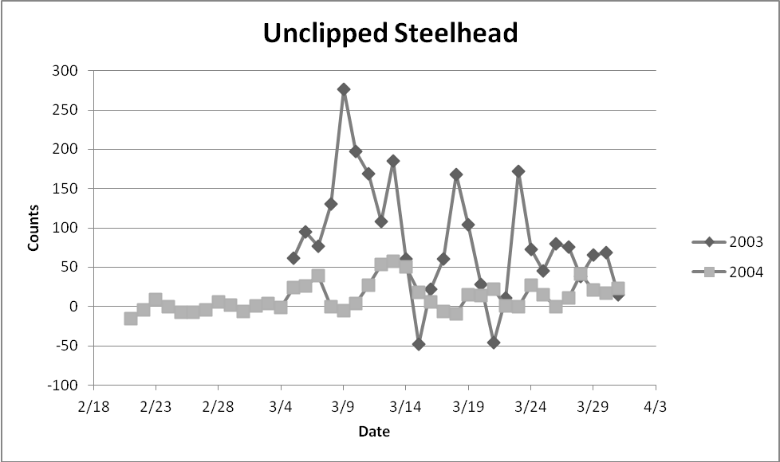
Figure 1. JDA unclipped steelhead passage in early spring for 2003 and 2004.

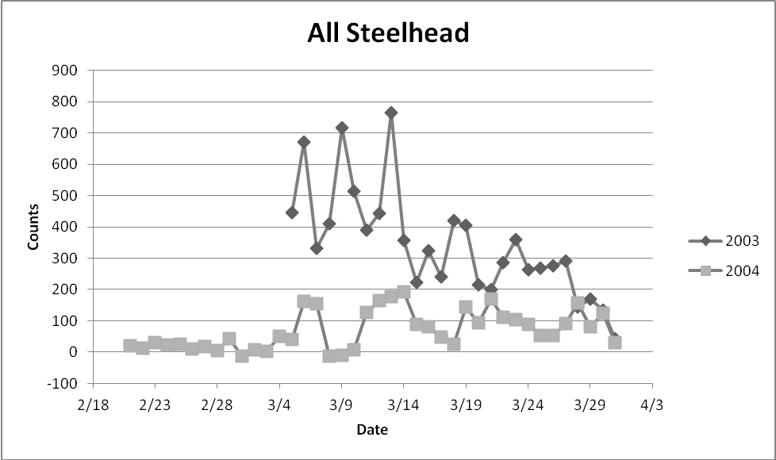
Figure 2. JDA total steelhead passage in early spring for 2003 and 2004.

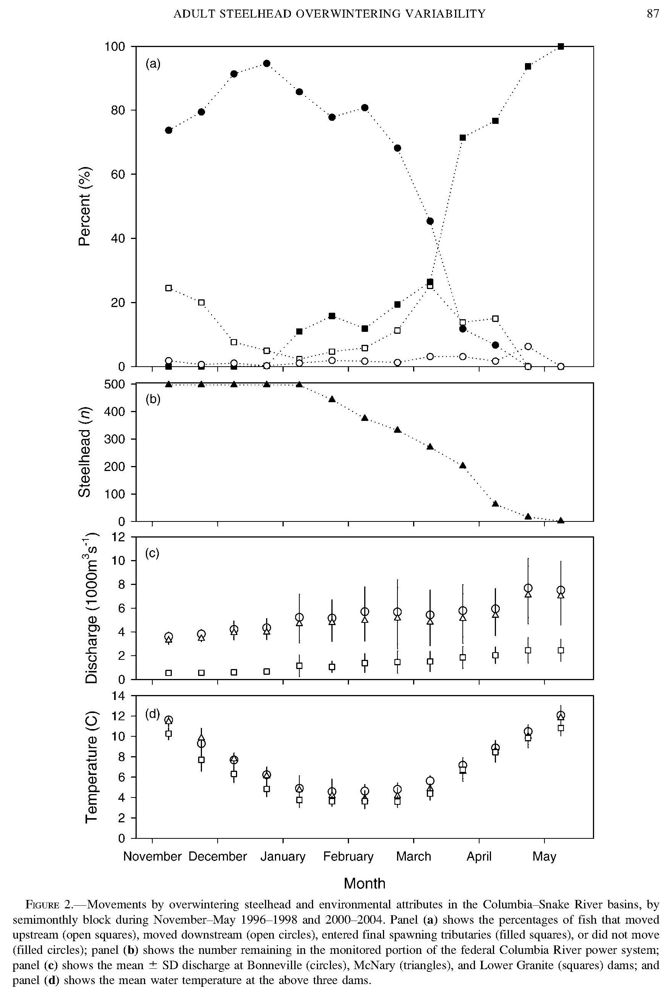
Figure 3. Keefer et al 2008 overwintering steelhead behavior paper (NAJFM 2881-96, Figure 2)
Current comments from others-
NOAA Fisheries- -----Original Message-----
From: Gary Fredricks [mailto:gary.fredricks@noaa.gov]
Sent: Wednesday, January 18, 2012 2:01 PM
Subject: Re: FW: John Day South Fish Ladder Outage
In looking at Keefer et al 2008 overwintering steelhead behavior paper (NAJFM 28:81-96, Figure 2) it is pretty clear that once mid-February rolls around, these fish are starting to move. Before mid-Feb, movement is pretty low and not that different from January. These data reflect movements from six years of tagging efforts and the authors indicated that this behavior was consistent from year to year. This trend also seems to be reflected in the count data Trevor presented, however, it is unfortunate that the data do not cover the time period in question. Tammy, in order to get these turbine pumps rehabbed, I think the risk of a dual ladder outage in early February to overwintering steelhead is fairly low. Not ideal by any means, but potential failure of the south shore ladder system certainly overshadows the risk in my opinion. Thanks, Gary

CRITFC- -----Original Message-----
From: Tom Lorz [mailto:lort@critfc.org]
Sent: Tuesday, January 17, 2012 3:25 PM
To: Mackey, Tammy M NWP
Subject: Re: FW: John Day South Fish Ladder Outage
Not that excited about that, but might be able to live with it. I assume it would be too big a job to dewater, get the turbine work done and then re-water. Once North ladder comes back, then dewater and do the necessary work in the south ladder, that way there would only be a couple of days of dual ladder outage. food for thought. tom

Final Action- This action did not go forward as coordinated.

The contractor is not able to meet the 13-15 February dates. NWP is now looking at coordinating an AWS outage in late February to allow divers to access the bulkhead and remove it. That coordination will occur at the February FPOM or through a new coordination form.

The Project will dewater JDA-S for winter maintenance. The ladder will return to service by 13 February 2012.

Please email or call with questions or concerns.
Thank you,
Tammy

Tammy Mackey
NWP Operations Division Fishery Section
Columbia River Coordination Biologist
503-961-5733
Tammy.m.mackey@usace.army.mil

